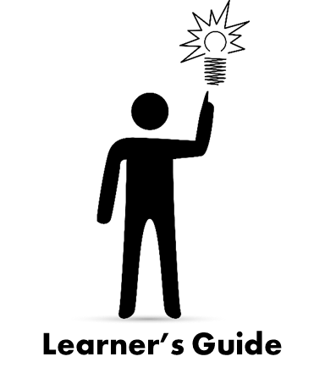
Authentic Assessment in Early Intervention

Authentic Assessment in Early Intervention 3
Lesson 1 – What is Authentic Assessment? 3
Define Authentic Assessment: 3
Core Activities of Authentic Assessment 3
Descriptive Statements are Important because… 3
Activity - DEC Recommended Practices – Review the “Assessment-Related” Practices 3
Activity - Pause & Reflect - Consider this quote: 4
Lesson 2- Understanding Why 5
Activity - Authentic Assessment to Functional Outcomes - Bennie 5
Activity - Practice What You Learned in Lesson 1 & 2 with Vladi 6
Activity - Reflection on Your Practices - Missed-It Team or Get’s-It Team? 7
Activity - Pause & Reflect - Consider this quote: 8
Lesson 3 – Who, Where, When & Within? 9
WHO provides input during authentic assessment? 9
WHERE can authentic assessment take place? 9
WHEN does authentic assessment occur? 9
WITHIN which parts of the EI Process does authentic assessment occur? 9
Activity - Pause & Reflect - Intake/First Contacts 10
Authentic Assessment & Eligibility Determination 11
IFSP Development 11
Activity - Pause & Reflect – Family Centered Functional Outcomes (IFSP Outcomes) 11
Early Intervention Service Implementation & Progress Monitoring 12
Activity - Pause & Reflect - Consider this quote: 12
Lesson 4 – Putting it All Together 13
Lesson 1 – What did you learn about the two core activities? 13
Lesson 2 – Why is authentic assessment important? 13
Lesson 3 – What did you learn about how authentic assessment can support the work you do with children and families within the EI process? 13
Activity - Reflection 14
Activity - Now It’s Your Turn 15
Activity - Pause & Reflect - Consider this quote: 16
Key Resources and References 17

Authentic Assessment in Early Intervention
The purpose of this Learner’s Guide is to be a companion tool for individuals completing the Universal Online Part C EI Curriculum module titled, Authentic Assessment in Early Intervention. It includes a general outline of content covered within the module, space to take notes as you follow along, reflective “Learner’s Guide” activities embedded within the module, as well as key resources and references.

Lesson 1 – What is Authentic Assessment?
This lesson focuses on what authentic assessment is and the two core activities that are included in authentic assessment, observing and gathering information from others. Use the space provided below to take notes and reflect on activities when prompted with the “Learner’s Guide” icon.

Define Authentic Assessment:

Core Activities of Authentic Assessment
Objective Observation includes: | Gathering Information includes:

Descriptive Statements are Important because…

DEC Recommended Practices - Review the “Assessment-Related” Practices

(https://divisionearlychildhood.egnyte.com/dl/tgv6GUXhVo)

Pause & Reflect - Consider this quote:
“Authentic assessment captures real-life behavior in everyday settings and routines. It has the flexibility to accommodate the functional limitations of children with various disabilities. It enables children to show what they can really do in a way possible, not merely the way prescribed by the test.” - Source: http://archive.brookespublishing.com/author-interviews/bagnato-70472-interview.htm”
Now, on a scale of 1 to 5 (with 5 being very confident) reflect on the following statements as they relate to your ability to perform and participate in authentic assessment activities in early intervention. There are no right or wrong answers, just your honest opinion of your skills, strengths and areas you’d like to develop.
Reflection Statements | 1 (not confident at all) 5 (very confident)
How confident am I in writing objective and descriptive observation statements? | 1 2 3 4 5
How confident am I in gathering information from family members and other caregivers? | 1 2 3 4 5
How confident am I in observing children in routines and activities (i.e. meal time)? | 1 2 3 4 5
Skills I’d like to practice and/or seek support related to objective observations, writing objective and descriptive statements and/or gathering information from family members and other caregivers:

Questions I have for a peer or supervisor who might help me work on these skills:

Lesson 2- Understanding Why
This lesson focuses on why authentic assessment is important. Use the space provided below to take notes and reflect on activities when prompted with the “Learner’s Guide” icon.

Information gathered through authentic assessment informs the following:
Functional Abilities – Skills used within daily routines
Functional IFSP Outcomes – meaningful & measurable (**check with your program to be sure you know what is expected for how these are written within the EI System you serve)
EI Implementation – intervention strategies that focus on achieving IFSP outcomes, strengths, abilities, family priorities and routine activities

Activity - Authentic Assessment to Functional Outcomes - Bennie
Imagine you are part of a team developing a functional IFSP outcome. Use the authentic assessment information provided below and develop a possible IFSP outcome for Bennie and his family. Remember, outcomes are never written by any one individual and are always written with the IFSP team. Tips for writing good outcomes can be found on the ECTA Center website (http://ectacenter.org/topics/ifsp/ifsp.asp). When finished, please return to the presentation and press play.
Functional Abilities: (objective/descriptive observation)
Bennie sits at the table in the childcare center during lunchtime and watches the other children pick up their spoons. He then picks up his spoon with a wide handle and scoops his food independently from the three section plate.
Family Priority:
Bennie’s parents would like him to feed himself with a spoon, like he does at childcare, so they don’t have to feed him or clean up the mess he makes with his hands.

Possible Functional IFSP Outcome: (** Please check with your program if you are uncertain about the level of details that need to be included in functional IFSP outcomes within the EI System you serve.)

Activity - Practice What You Learned in Lesson 1 & 2 with Vladi
Vladi is learning to use his legs and his mother is trying to help him practice his skills so he can crawl and reach to get to something he wants on his own. Vladi’s mother decided to video tape an activity she has been working on with him and is requesting feedback from her team members so she can help him be more independent as he explores new toys and objects at home.
Consider what you have learned from lesson 1 and lesson 2 and use the space below to document your descriptive observations, any follow up questions you have for the family, and strategies you might consider if you were providing EI for Vladi and his family.
When you are ready, click this link: https://www.youtube.com/watch?v=feWu4VxcRU8 to watch the first 4 minute video of Vladi. The video will open in a new window.
What do you see Vladi doing?

What do you observe Vladi’ mother doing?

How are Vladi’s siblings involved in the activity?

What are some of Vladi’s “functional abilities”?

What questions do you have for Vladi’s mother?

What EI implementation strategies might you suggest based on what you observed?

When finished, return to the presentation and press play.

Activity - Reflection on Your Practices - Missed-It Team or Gets-It Team?
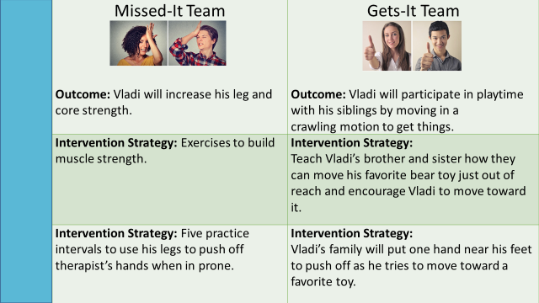

Now consider the outcomes and implementation strategies and activities that you develop with families and other team members.

Do they look more like the “Missed-It Team,” the “Gets-It Team” or somewhere in between? If they look more like the “Missed-It Team” or somewhere in between, what will you try to bring you closer to the “Gets-It Team”?

When finished, return to the presentation and press play.

Pause & Reflect - Consider this quote:
“Professionals on assessment teams often have two choices. They can rely solely on what they observe during the child’s performance of assessment tasks prescribed by the tool they are using. Or, they can integrate these and other observations with what they learn from talking with caregivers about the child’s abilities and challenges in everyday life. Relying on the child’s performance alone can be necessary, depending on the tool being used, but it is always important to remember that one tool, or even a child’s performance of discrete tasks, can never truly tell you all you need to know about a child’s abilities.” – Source: http://veipd.org/earlyintervention/2017/03/30/dec-recommended-practices-assessment-part-2/

How can you improve your skills? Are your IFSP outcomes written to reflect functional abilities? What skills would you like to practice to build on those functional abilities?

Lesson 3 – Who, Where, When & Within?
This lesson explores who participates in authentic assessment, where it may happen, when it can be done, and within what early intervention processes it can occur during a family’s journey through early intervention. Use the space provided below to take notes and reflect on activities when prompted with the “Learner’s Guide” icon.

WHO provides input during authentic assessment?

WHERE can authentic assessment take place?

WHEN does authentic assessment occur?

WITHIN which parts of the EI Process does authentic assessment occur?

Pause & Reflect - Intake/First Contacts
Take a moment to think about the authentic assessment activities you engage in during intake visits with families. For service providers, who may not perform “intake” activities, you may reflect on the tools, questions and strategies you use to help get to know families during your initial contact with them.
- What questions do you ask? Are they open-ended questions that allow families to share or elaborate on information?

- What other ways do you collect information, review and act on what you’ve learned from the family and through your observations?

- How do you observe the child and family interacting in daily routines/activities that they are seeking support with during this visit?

- How do you share the information you have gathered with other team members?

When you are ready, return to the presentation and press play

Authentic Assessment & Eligibility Determination
It is through authentic assessment that team members gain a better idea of how accurate their findings are and may subsequently use their informed clinical opinion for eligibility determination. The DEC Recommended Practices inform us that practitioners are to use clinical reasoning in addition to evaluation/assessment results to identify the child’s current levels of functioning and to determine the child’s eligibility and plan for instruction. For more information on authentic assessment and informed clinical judgement as it pertains to eligibility determination please check with your state’s early intervention policies and procedures.

IFSP Development
After children and families are determined eligible for early intervention, authentic assessment is also used in IFSP development including family centered functional outcomes and federal reporting of the three child outcomes. If your state uses the Child Outcome Summary (COS) Process then you may find the Decision Tree to be a helpful tool to determine child outcome ratings.

Pause & Reflect – Family Centered Functional Outcomes (IFSP Outcomes)
Take a moment now to think about a recent IFSP meeting you participated in and consider how you may have used authentic assessment to help inform and develop IFSP outcomes.
What strategies do you use to connect authentic assessment and development of IFSP outcomes?

When you are ready please return to the presentation and press play.

Early Intervention Service Implementation & Progress Monitoring
- Every time the family and service providers interact, they have an opportunity to share information and observe the child in action.
- Authentic assessment can also be used to help monitor the IFSP and progress that children and families are making as a result of their participation in early intervention. Progress monitoring is essential for determining changes, progress, and appropriateness of intervention.
- IFSP outcomes are a great tool to prompt questions in a variety of settings and situations. Progress monitoring is ongoing and may occur more formally at six month reviews, annual IFSP reviews and discharge (or exit summary).

Pause & Reflect - Consider this quote:
“One-time observations even in the natural context, are insufficient and often misleading” – Source: Bagnato, Neisworth, Pretti-Frontczak, 2010
How does your early intervention program determine who will be involved with authentic assessment? Are there times and places within the IFSP process that you are using authentic assessment and never realized that was indeed what you were doing? Where within the early intervention process might you add more authentic assessment?

Lesson 4 – Putting it All Together
This lesson will briefly review what has been learned in this module and provide activities as you work to develop or refine your skills. Use the space provided below to take notes and reflect on activities when prompted with the “Learner’s Guide” icon.

Lesson 1 – What did you learn about the two core activities?

Lesson 2 – Why is authentic assessment important?

Lesson 3 – What did you learn about how authentic assessment can support the work you do with children and families within the EI process?
- Intake

- Evaluation/Assessment/Eligibility

- IFSP Development

  - Child Outcomes

  - IFSP Outcomes

- Service Implementation

- Progress Monitoring

Activity - Reflection

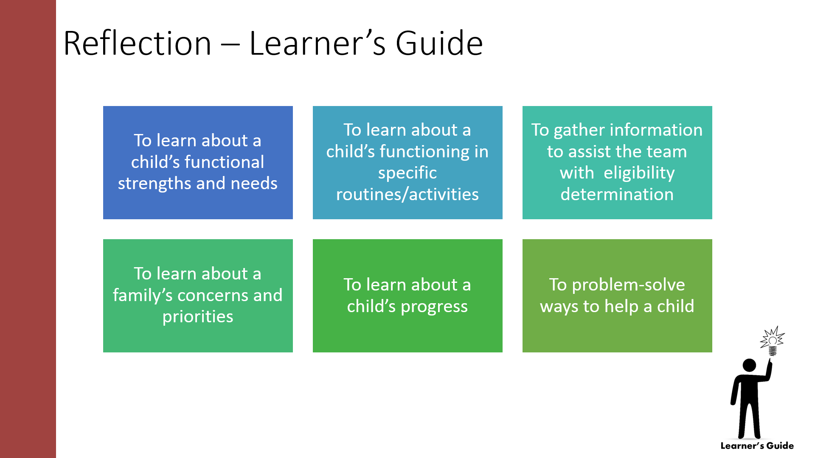

Based on all this information you’ve learned on authentic assessment, think about your work every day with children and families. Have you used, or how could you use, authentic assessment during any of these activities?

What tools do you use to expand information gathered and observed? How can family videos provide additional information as you review, reflect and consider actions within the EI process?

Activity - Now It’s Your Turn
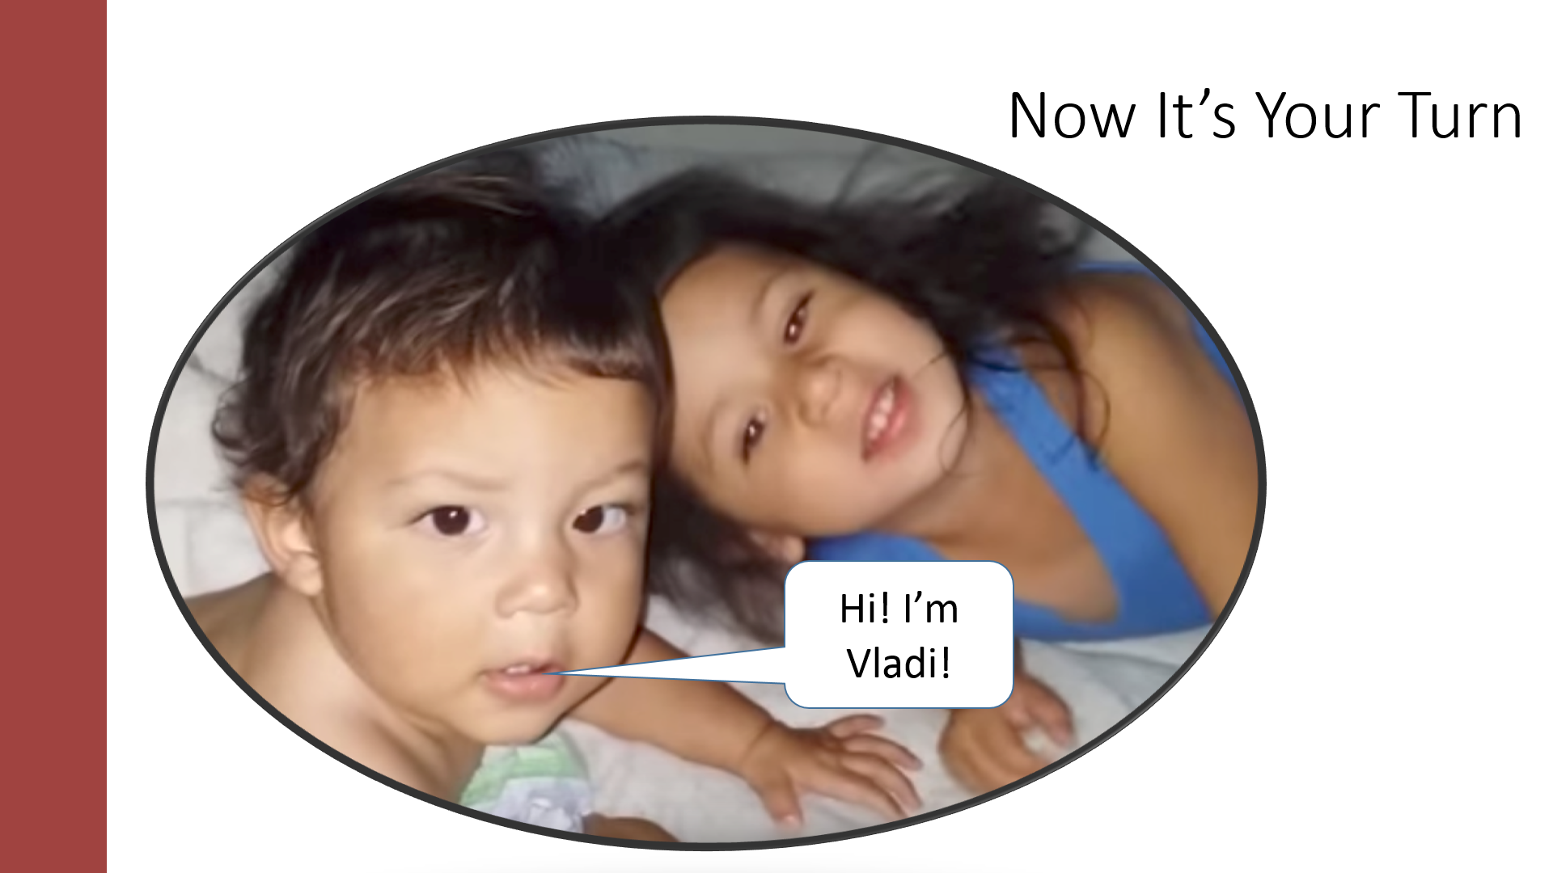
As you watch this video, use the space provided to record your objective observations, Vladi’s functional abilities, questions you might ask for review and next steps.
Record your objective observations? What information did you gather?

What functional abilities did you observe? How might this tie to family priorities which could lead to an outcome?

What would you review/reflect on with the family? What questions would you ask?

Within which step(s) of the EI process might a video like this support? What actions might need to be considered?

Pause & Reflect - Consider this quote:
Bronfenbrenner notes that assessment should NOT be:
"...the science of strange behavior of children in strange situations with strange adults for the briefest possible periods of time." – Source: Bronfenbrenner, U. (1979). The Ecology of Human Development: Experiments by Nature and Design Cambridge, MA. Harvard University Press. p. 19

How will you use your newly gained information on authentic assessment? Document two changes in your practice you would like to make regarding authentic assessment.

Key Resources and References

Bagnato, S., Goins, D., Pretti-Frontczak, K. (2010). LINKing Authentic Assessment and Early Childhood Intervention: Best Measures for Best Practices, Second Edition. Baltimore, MD. Brookes Publishing.

Bronfenbrenner, U. (1979). The Ecology of Human Development: Experiments by Nature and Design. Cambridge, MA. Harvard University Press. p. 19.

Brookes Publishing. Author Q & A: What are the Advantages of Using Authentic Assessment for Early Childhood Intervention? http://archive.brookespublishing.com/author-interview/bagnato-70472-interview.htm.

Childress, D.C. “DEC Recommended Practices: Assessment (Part 2)” Early Intervention Strategies for Success, 30 March 2017, http://veipd.org/earlyintervention/2017/03/30/dec-recommended-practices-assessment-part-2/

Division of Early Childhood Recommended Practices, 2014. Select ASSESSMENT tab. Available at: http://ectacenter.org/decrp/decrp.asp

ECTA Center was charged with assisting the Division for Early Childhood with developing products that would promote the use of the DEC Recommended Practices. The ECTA DEC Recommended Practices (RP) products illustrate how practitioners and parents can use the different RPs. These are the Checklists and Practices Guides for children and families related to Assessment.
- Engaging Families as Partners in Their Child's Assessment Checklist
- Informed Clinical Reasoning Checklist
- Authentic Child Assessment Practices Checklist
- Building on Child Strengths Practices Checklist
- Engaging Families as Assessment Partners (Practice Guide)
- Authentic Child Assessment (Practice Guide)
- Building on Child Strengths (Practice Guide)
- Identifying Child Strengths (Practice Guide)
- Family Member Roles in Informed Clinical Reasoning (Practice Guide for Families)
- Partnering with Your Child's Assessment Team Members (Practice Guide for Families)
- Everyday Child-and-Family Activities (Practice Guide for Families)
- Building on My Child's Strengths (Practice Guide for Families)
- Seeing My Child's Strengths (Practice Guide for Families)

Early Childhood Technical Assistance Center. Resources for Writing Good IFSP Outcomes.
http://ectacenter.org/topics/ifsp/ifsp.asp

Early Childhood Technical Assistance Center. Questions for Eliciting Family Interests, Priorities, Concerns & Everyday Routines and Activities.
http://ectacenter.org/~pdfs/knowledgepath/ifspoutcomes-iepgoals/QuestionsEverydayActivities.pdf

Early Intervention Strategies for Success Blog: http://veipd.org/earlyintervention/
Functional AND (not or) Traditional Assessment
DEC Recommended Practices: Assessment (Part 1)
DEC Recommended Practices: Assessment (Part 2)

Infant & Toddler Connection of Virginia. The Decision Tree: Child Indicator Seeds for Success - Functional Assessment
http://www.veipd.org/main/pdf/functional_assessment_11.2014_desicion_tree.pdf

Infant & Toddler Connection of Virginia. Asking Good Questions http://www.veipd.org/main/pdf/Quik_Ref_Guide-Asking_GOOD_Questions_June_2013.pdf

